RESOLUTION NO.__________

RE: CERTIFICATE OF APPROPRIATENESS UNDER THE
PROVISIONS OF THE ACT OF THE PENNSYLVANIA
LEGISLATURE 1961, JUNE 13, P.L. 282 (53
SECTION 8004) AND BETHLEHEM ORDINANCE NO.
3952 AS AMENDED.

WHEREAS, it is proposed to replace the awning on the first floor storefront window at 81 W. Broad St.

NOW, THEREFORE, BE IT RESOLVED by the Council of the City of Bethlehem that a Certificate of Appropriateness is hereby granted for the proposal.

Sponsored by: (s)

(s)

ADOPTED BY COUNCIL THIS DAY OF

(s)
President of Council

ATTEST:

(s)
City Clerk

HISTORICAL & ARCHITECTURAL REVIEW BOARD

The applicant proposes to replace the first floor storefront window awning at 81 W. Broad. St.
APPLICATION #3:

Domenic Villani
81 W. Broad St.
Bethlehem, PA 18018

OWNER:

__________________________________________________________________

The Board upon motion by Phil Roeder and seconded by Marsha Fritz adopted the proposal that City Council issue a Certificate of Appropriateness for the following:

- To install a Black Sunbrella fabric awning with Green lettering reviewed by the Historic Officer.

2. The awning will have open ends same as the existing awning.

3. The motion was unanimously approved.

__________________________________________________________________________

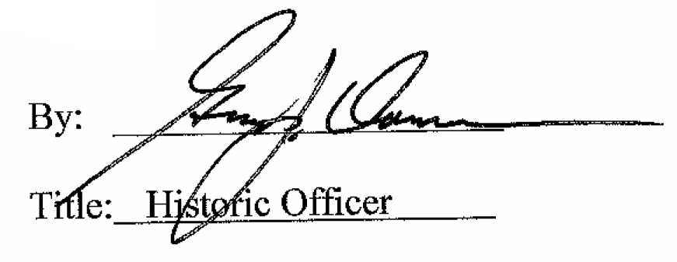

Date of Meeting: November 4, 2015

